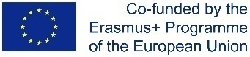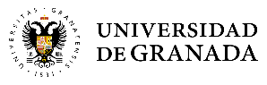

**Máster Erasmus Mundus en Estudios de las Mujeres y de Género**

**Erasmus Mundus Master’s Degree in Women’s and Gender Studies**

*TITLE*

NAME AND SURNAME

Submitted to the Department of Modern Languages, Literatures and Cultures University of Bologna,

Degree Programme in Modern, Post-colonial and Comparative Literatures

in fulfilment of the requirements for the Erasmus Mundus Master’s Degree in Women's and Gender Studies

**Approved by:**

Main Supervisor:

Support Supervisors:

**Academic year:**

**Instituto Universitario de Investigación de Estudios de las Mujeres y de Género │Calle Rector López Argüeta s/n │ Centro de Documentación Científica │ Universidad de Granada │18071 Granada │tel.: +34958244349 │fax:34958242828 │ email:** [**gemma@ugr.es**](mailto:gemma@ugr.es) **│web:** [**http://masteres.ugr.es/gemma/**](http://masteres.ugr.es/gemma/)

 *    *